Data Handling and Visualization (DSA06)
Name: Prasanna M Reg. No: 1925260244
Set 29: Student Academic Performance
Question 1. Using R, create a stacked area chart showing Test_Score and Participation_Score across students. Analyze trends.
Program (R):
library(ggplot2); library(tidyr)
students <- data.frame(Student_ID = paste0("S", 1:5), Age = c(19,21,20,22,23),
Study_Hours = c(12,8,15,10,7), Attendance = c(90,70,95,85,60),
Test_Score = c(85,70,92,80,65), Participation_Score = c(8,7,9,8,6))
long <- pivot_longer(students, cols = c(Test_Score, Participation_Score), names_to = "Measure", values_to = "Score")
ggplot(long, aes(x = Student_ID, y = Score, fill = Measure, group = Measure)) +
geom_area(position = "stack", colour = "white") +
labs(title = "Test Score and Participation Score by Student", x = "Student", y = "Score (stacked)") +
theme_minimal()
Output:
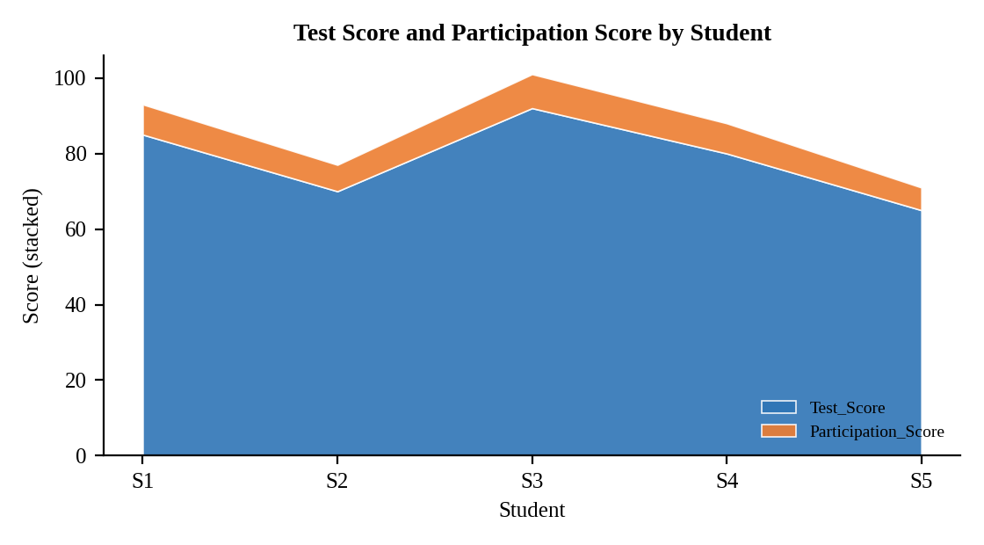
Interpretation:
The stacked total is highest for S3 (101) and lowest for S5 (71), and both layers rise and fall together: S3 has the best test score (92) and participation (9), and S5 the lowest of both (65 and 6). Participation is on a much smaller scale than test score, so it forms a thin band; the shared pattern shows that more active students tend to score higher.

Question 2. Using R, generate a boxplot of Study_Hours grouped by Attendance quartiles. Interpret patterns. Include axis labels, title, and colors for each quartile. Analyze the boxplot to identify median and interquartile range of study hours per attendance quartile and any outliers in study hours.
Program (R):
brk <- quantile(students$Attendance, probs = seq(0, 1, 0.25))
students$Att_Quartile <- cut(students$Attendance, breaks = brk, include.lowest = TRUE,
labels = c("Q1 (60-70)","Q2 (70-85)","Q3 (85-90)","Q4 (90-95)"))
ggplot(students, aes(x = Att_Quartile, y = Study_Hours, fill = Att_Quartile)) +
geom_boxplot() +
labs(title = "Study Hours by Attendance Quartile", x = "Attendance Quartile (%)", y = "Study Hours") +
theme_minimal() + theme(legend.position = "none")
Output:
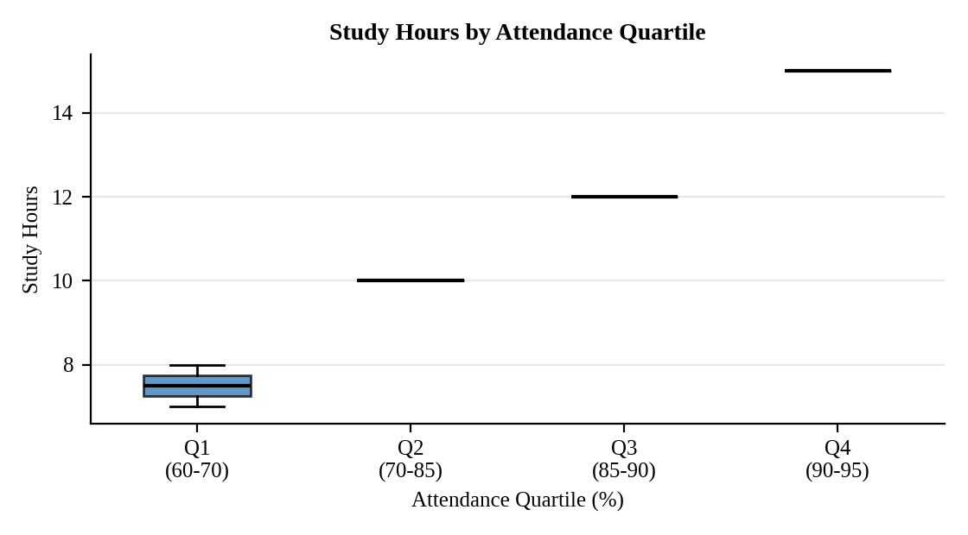
Interpretation:
Median study hours rise with each attendance quartile: 7.5 (Q1, IQR 0.5), 10 (Q2), 12 (Q3) and 15 (Q4). Q2, Q3 and Q4 each contain one student, so their boxes collapse to a line with an IQR of 0. No outliers appear in study hours. Students who attend more also study more.

Question 3. Using R, construct a density plot for Test_Score to evaluate score distribution and outliers.
Program (R):
ggplot(students, aes(x = Test_Score)) +
geom_density(fill = "steelblue", alpha = 0.5) +
geom_rug() +
labs(title = "Density Plot of Test Score", x = "Test Score", y = "Density") +
theme_minimal()
q <- quantile(students$Test_Score); iqr <- IQR(students$Test_Score)
c(lower = q[2] - 1.5 * iqr, upper = q[4] + 1.5 * iqr)
Output:
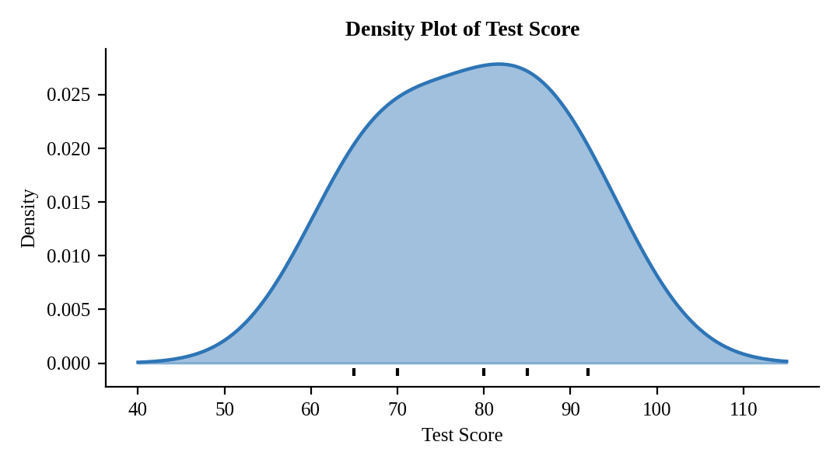
Interpretation:
Scores range from 65 to 92 with a mean of 78.4 and a median of 80; the curve is broad and fairly symmetric with a slightly longer tail towards the lower scores. The outlier limits are 47.5 and 107.5 (Q1 = 70, Q3 = 85, IQR = 15), so no score is an outlier.

Question 4. In Tableau, design an interactive scatterplot with Study_Hours on X-axis, Test_Score on Y-axis, colored by Participation_Score. Include filters for Age.
Procedure (Tableau):
1. Open Tableau, click Connect, choose Text file / Microsoft Excel, select "Student_Academic_Performance.csv" and open Sheet 1.
2. Columns = Study_Hours (SUM, continuous); Rows = Test_Score (SUM, continuous); drag Student_ID to Detail and Label; mark type = Circle.
3. Drag Participation_Score to Color (continuous gradient) and increase the mark Size.
4. Right-click Age, choose Show Filter, select Range and apply it to the sheet; add Age, Attendance and Participation_Score to Tooltip.
5. Click New Dashboard, name it "Student Scatter Dashboard", set Size to Automatic and drag the sheets onto the canvas.
6. Drag the scatter sheet to the dashboard canvas with the Age filter and the colour legend beside it; enable "Use as Filter" and hover tooltips.
7. Add a title to every sheet, adjust labels and colours, and save the workbook (File > Save As, .twbx).

Output:
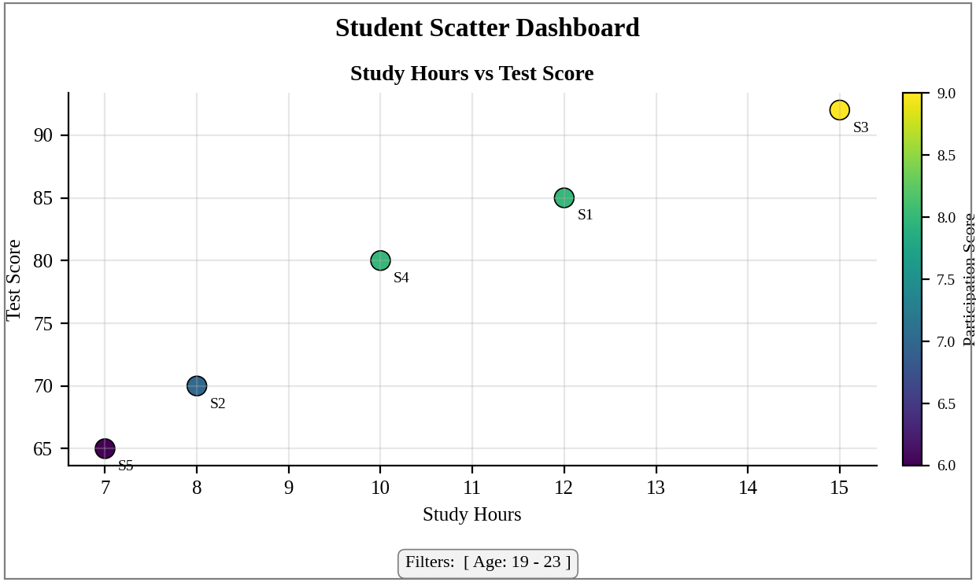
Dashboard layout (preview of the Tableau output).
Interpretation:
The scatter shows a very strong positive relationship between study hours and test score (r = 0.98), and the colour moves from low to high participation as both increase (S5 lowest, S3 highest). Moving the Age filter narrows the plot to chosen ages so a teacher can see how study time and participation relate to results.

